CHAPTER 2 COMPUTER HARDWARE

The physical parts of the computer are called hardware. The hardware is any part of a computer that you can see and touch.

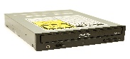

[This Photo](https://commons.wikimedia.org/wiki/File:ASUS_CD-ROM_CD-S520-A4_20080821.jpg) by Unknown Author is licensed under [CC BY-SA](https://creativecommons.org/licenses/by-sa/3.0/)

There are many other parts of a computer. Some parts of a computer are inside the computer, you can see them only when you open the CPU cabinet. Some parts are outside and they can be easily seen and touched by hand. Many parts are connected to the Central Processing Unit (CPU) through wires or cables.

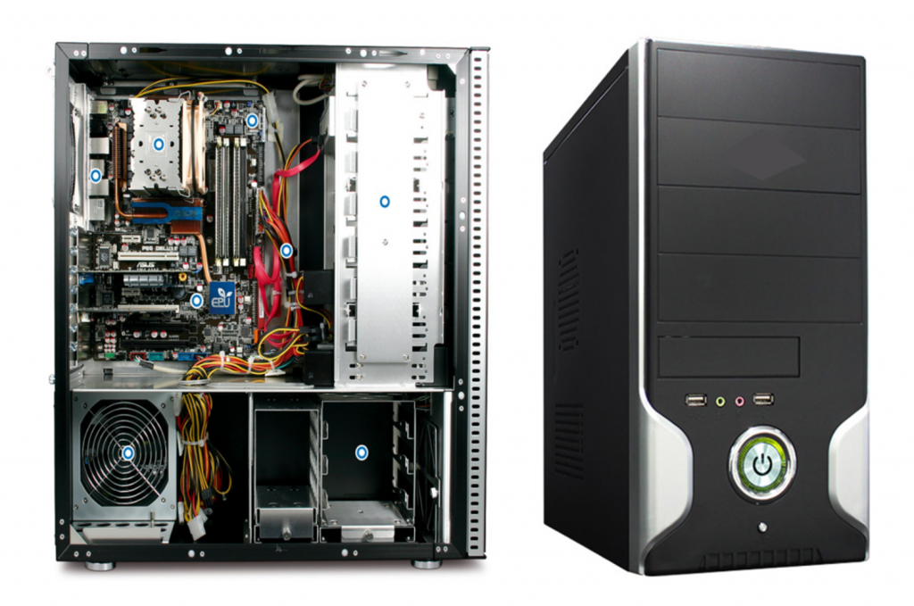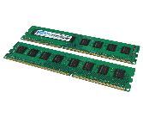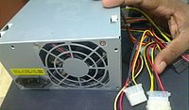

RAM

CD Drive

SMPS

ROM

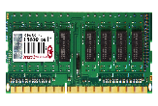

[This Photo](https://www.pngall.com/ram-png/download/48279) by Unknown Author is licensed under [CC BY-NC](https://creativecommons.org/licenses/by-nc/3.0/)